**2019-2**

**REPORT**

Web Programming Lab

Term Project

SKKU Flea Market Management Page



2019-2 Semester

문헌정보학과 2016313990 / 박동은

글로벌경제학과 2017310018 / 이선경

문헌정보학과 2016310925 / 홍연경

문헌정보학과 2017310301 / 김승윤

**#1 Functions**

1. **Common Page**

* **Registration**

Registration for the Kingo Market is divided into Buyer and Seller. Market users are required to fill out the form. If the user has not entered all the inputs, entered a different value in the password confirmation box, or entered an already existing ID, the registration will be failed.

-Buyer sign up:

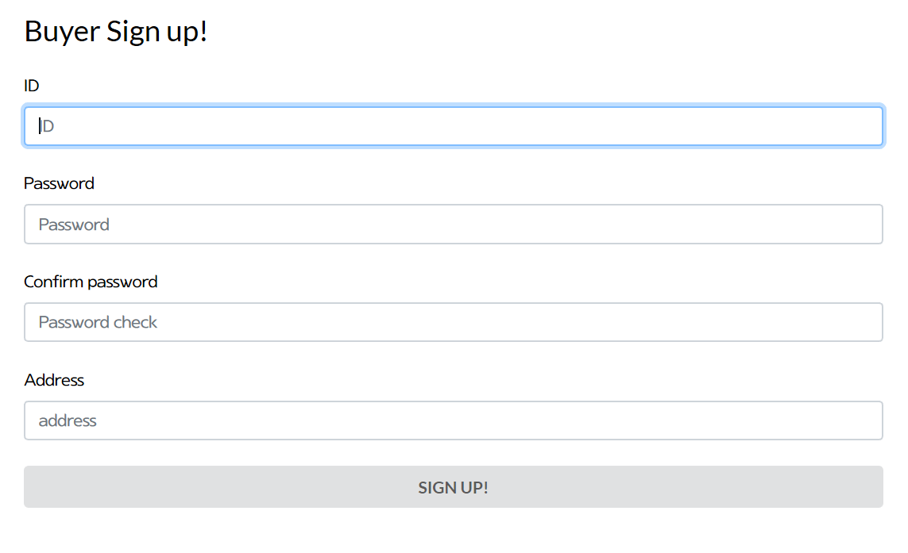

-Seller sign up:

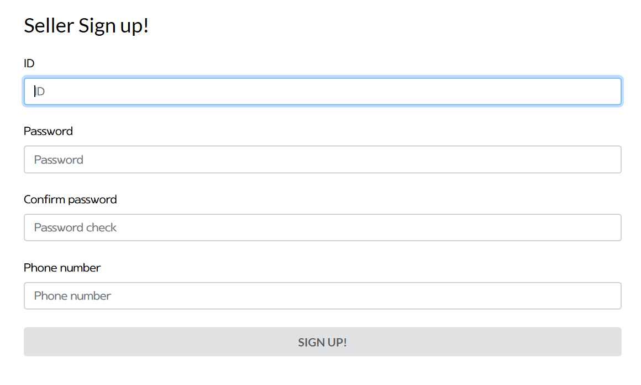

* **Login**

Users can login with ID and password.

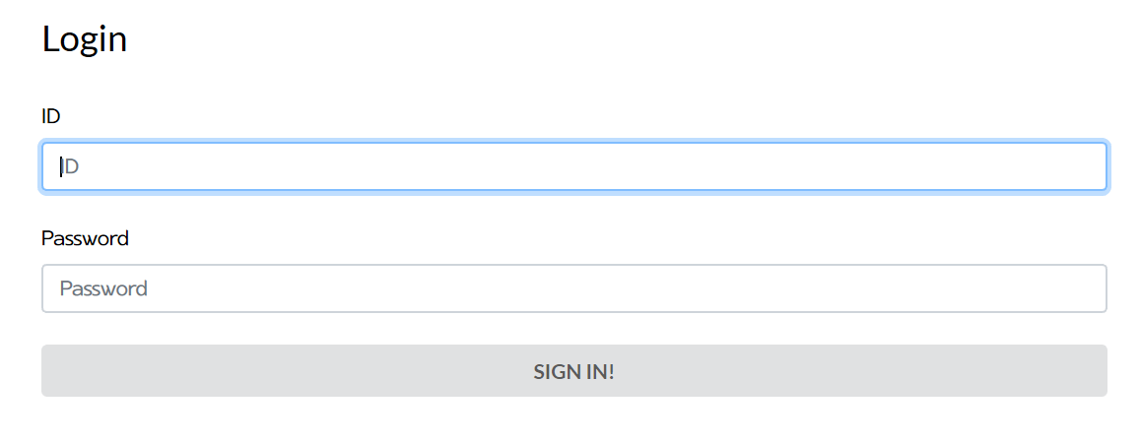

After login (if everything was successful):



* **Product list**

All Products registered in this Web page is displayed on the main page. Each card is linked to the product detail page and marked by tag to be classified into ‘auction’, ‘purchased’, ‘in progress’.

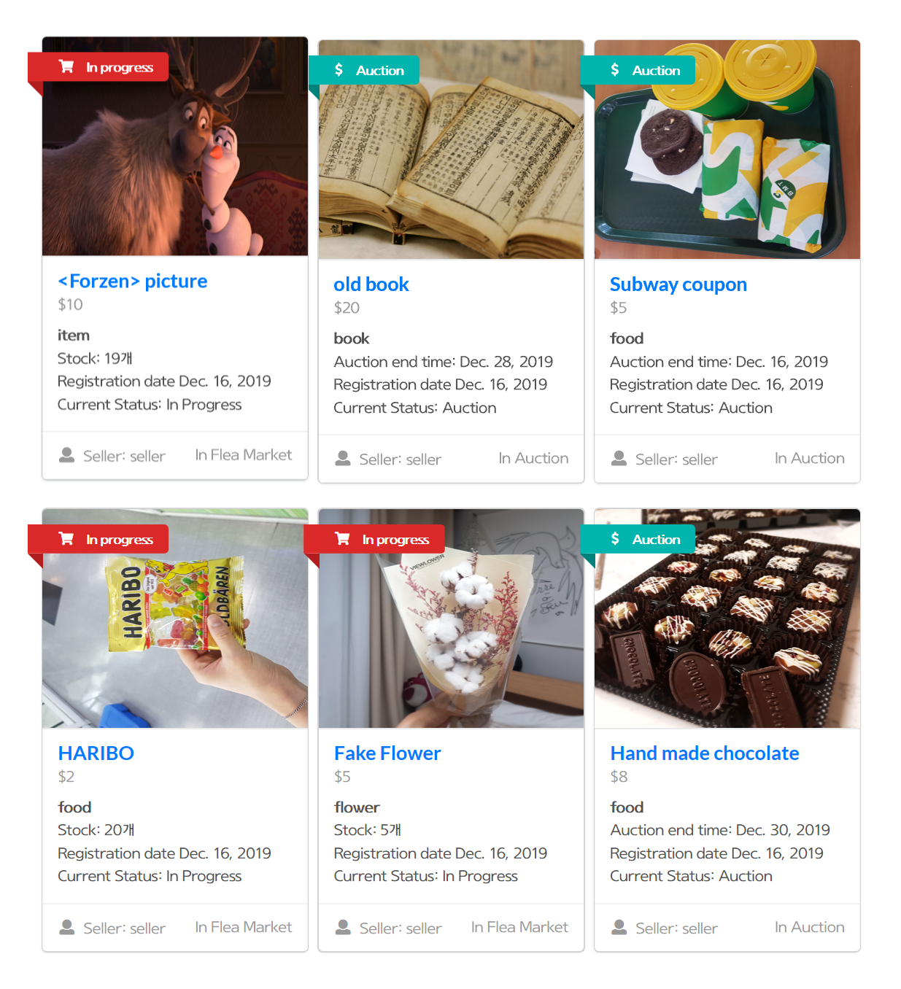 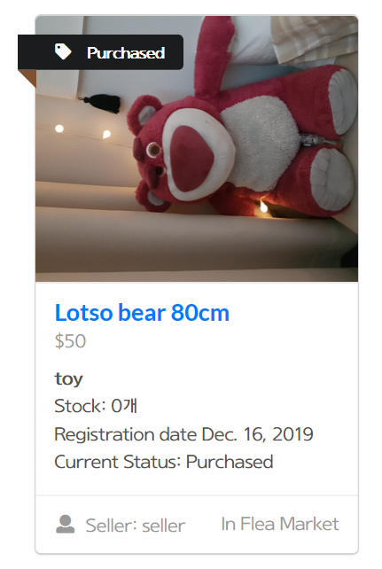

The card tag is changed to ‘purchased’ if the number of product stock is 0 or the auction is ended. ▲

* **Product detail**

Users can access product detail page by clicking the product card in the main page. This page provides detail information of the product such as the number of stocks, registered date, seller name, etc.

-Flea Market:

There is ‘Buy’ button to buy the product and ‘add to wish’ button to add the product in the wish list.

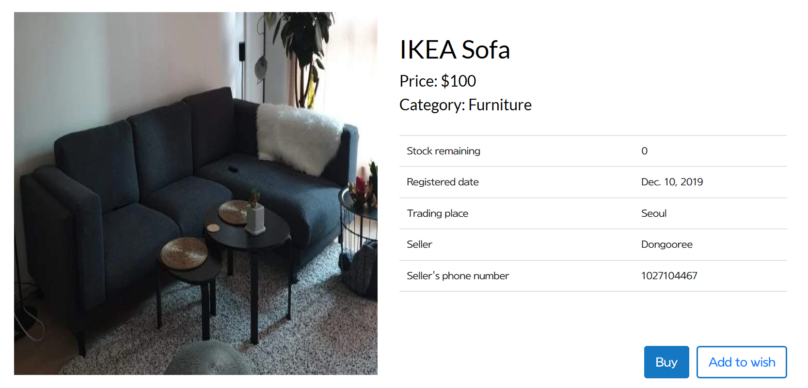

-Auction:

There are Input field to enter a bid price, ‘bid’ button is for submitting the price and ‘add to wish’ button is to add the product in user’s own wish list. If the end date of the auction has passed or if the buyer offers a price below the current price, the auction does not proceed.

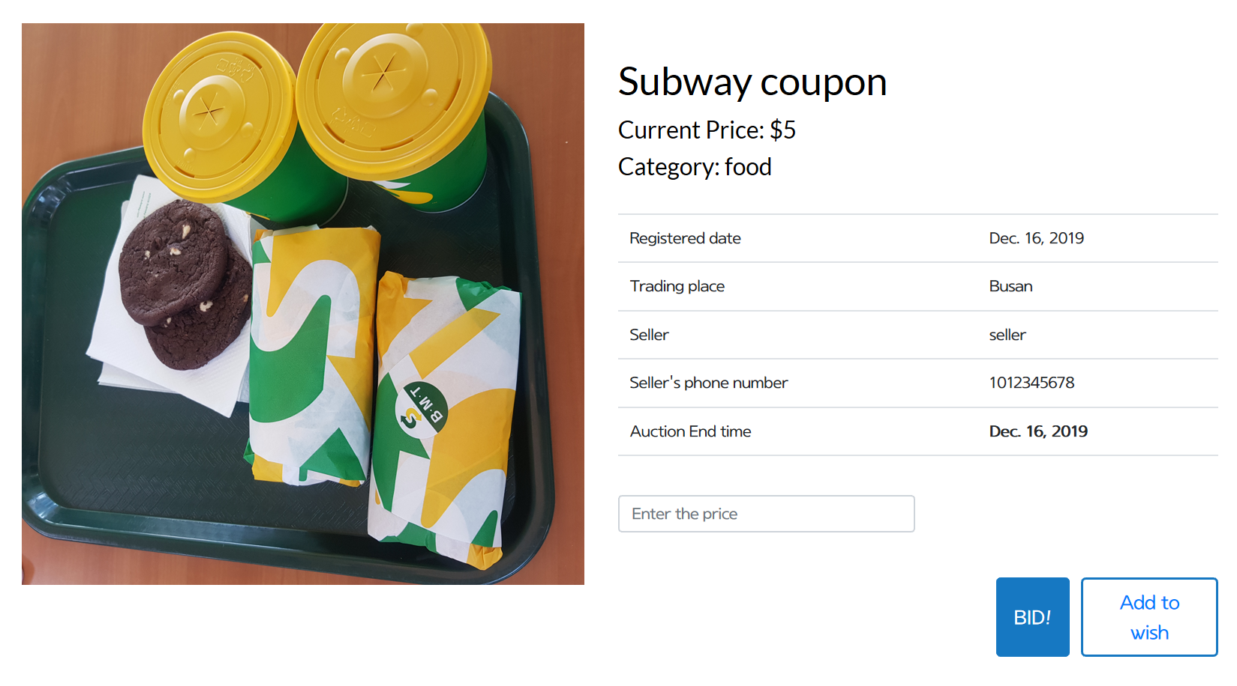

1. **Administrator**

We set administrator’s account separately. If manager sign in by administrator’s account, ‘Administration page’ appears. ‘Administration page’ is linked to site administration system provided by Django. Using this system, manager can add, delete, and modify member and products.



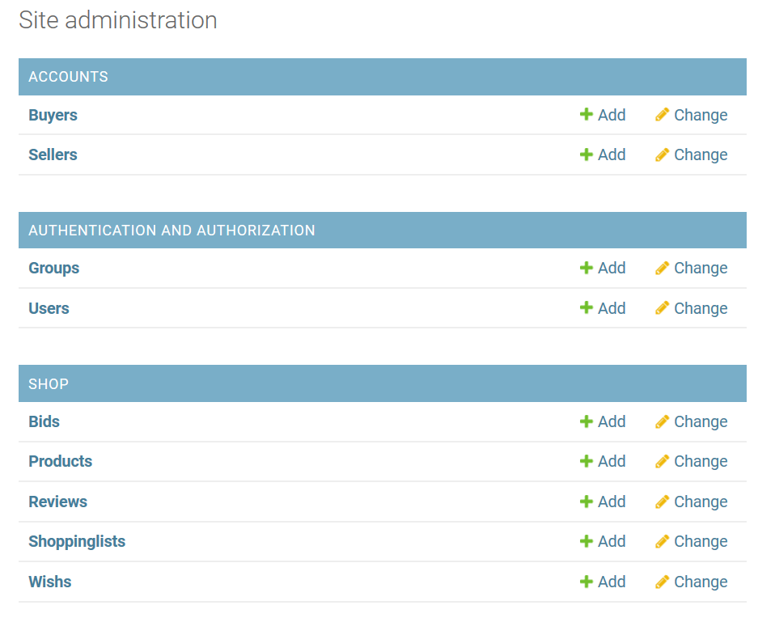

* **Member List**

-Modification of member information

Manager can check the member list and modify member’s information in the ‘Users’ table.

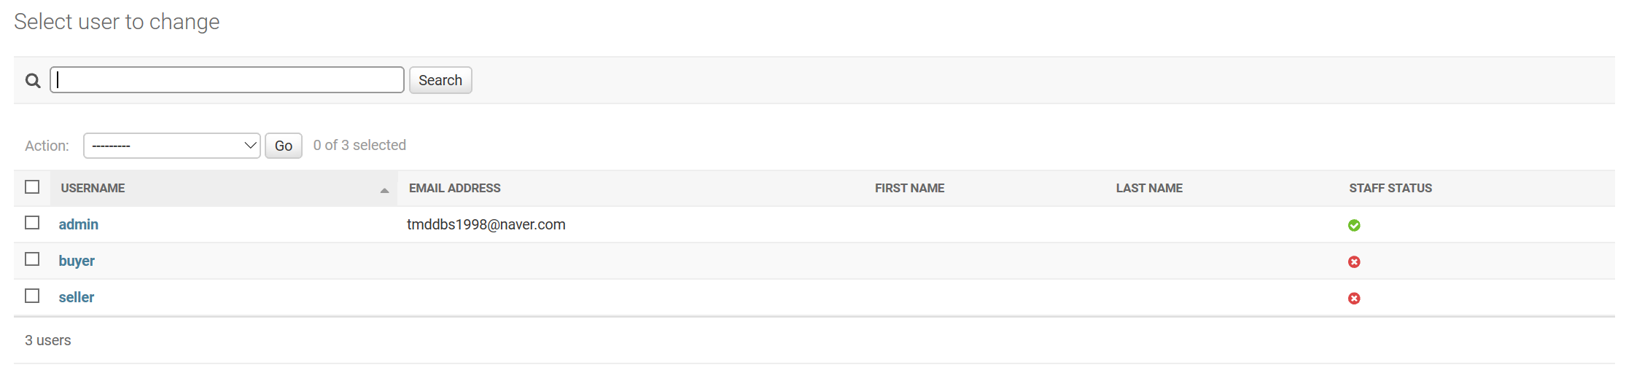

-Member deletion

‘Change’ button next to the buyer and seller table is linked to the page that can perform a member deletion.

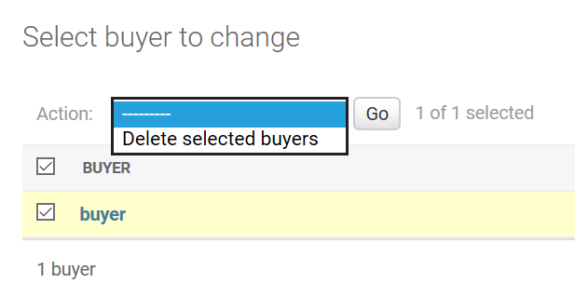

1. **Buyer**

* **Mypage**

‘Mypage’ show the user information. ‘Mypage’ of buyer includes user ID, address, shopping history (list of products the buyer bought through flea market), and auction history (list of products the buyer bought through auction)

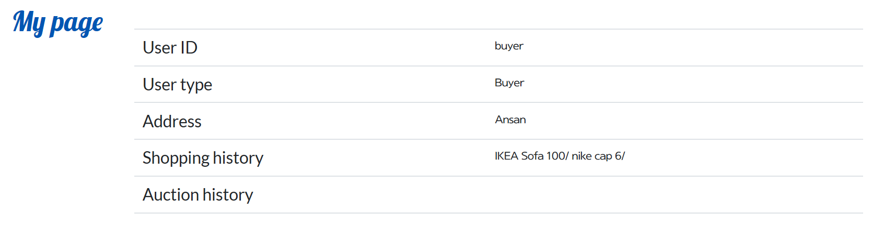

* **Product buy**

-Flea market

When seller clicks buy button, Kingo Market disallow them to buy.



When buyer clicks buy button, Kingo Market allow them to buy and add bought product in the buyer’s shopping list.



-Auction

User inputs a price to bid in the bid price field and click ‘bid’ button. If the bid price that the user entered is lower than the current price or the auction due date passes, bid is rejected.





If the bid price is larger then the current price, bid is registered. Then the current price is updated.



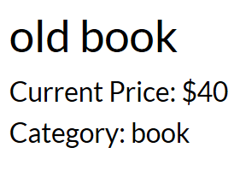→ 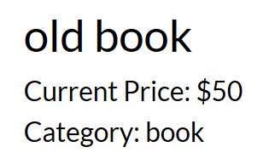

History of user’s bid status can be checked in user’s ‘mypage’.



* **Product search**

All users can search all products registered in Kingo Market. Users can retrieve products by typing ‘product name’ or ‘seller name’ in the search box. It is also possible to search products according to the type of market (flea market or auction), status (auction, purchased, in progress), and the amount of price. The result product of searching is shown next to the search boxes. Alignment method can be controlled as user chooses.

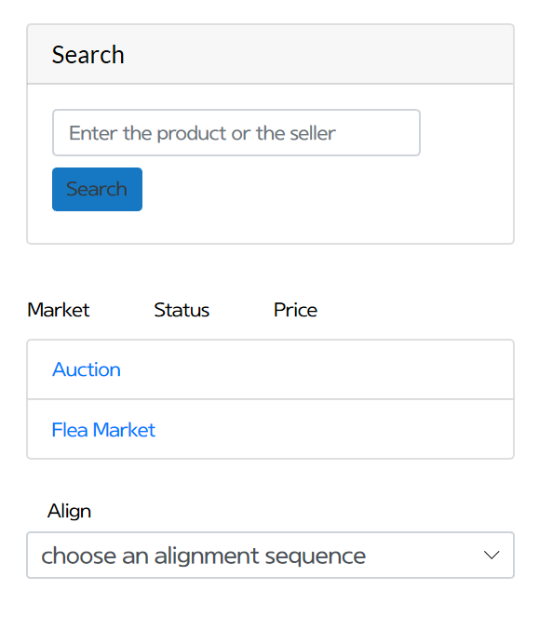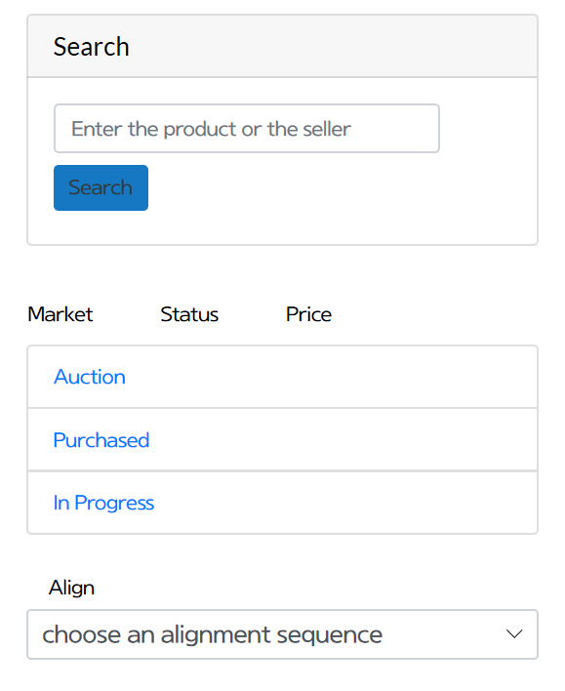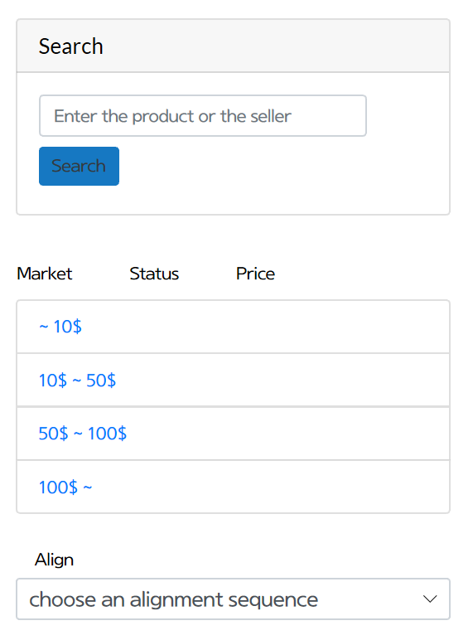

* **Shopping list**

All buyers have their own shopping list which contains the products they bought in this market. Total price of the whole products in the shopping list is calculated automatically.

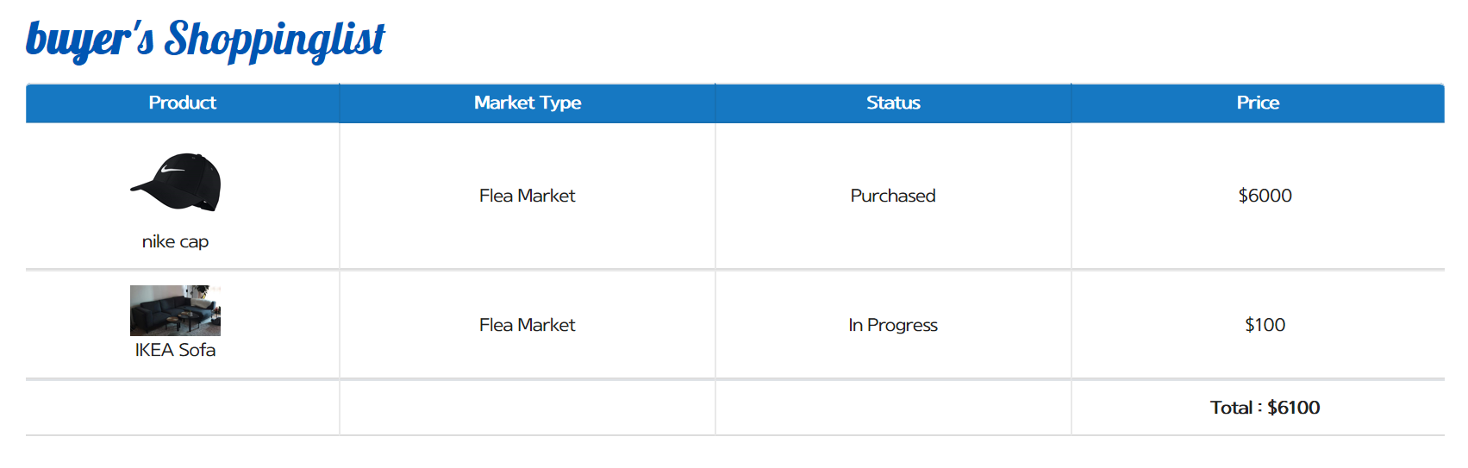

* **Wish list**

All users also have their own wish list. Users can add the product in the wish list before buy it if they like the product but are hesitated to buy. When they click ‘add to wish’ button next to the ‘buy’ or ‘bid’ button, the product is added to the wish list.



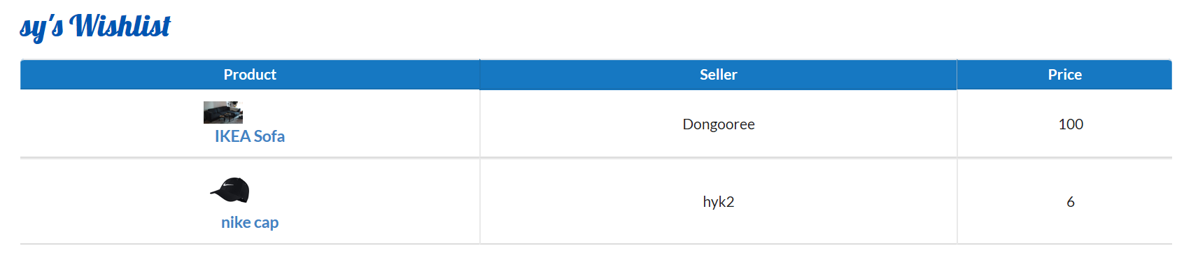

1. **Seller**

* **Product registration**

If the seller signed in have not registered product yet, product list for the seller tells ‘No products are listed’. ‘Register Your Product’ button is linked to product registration page.

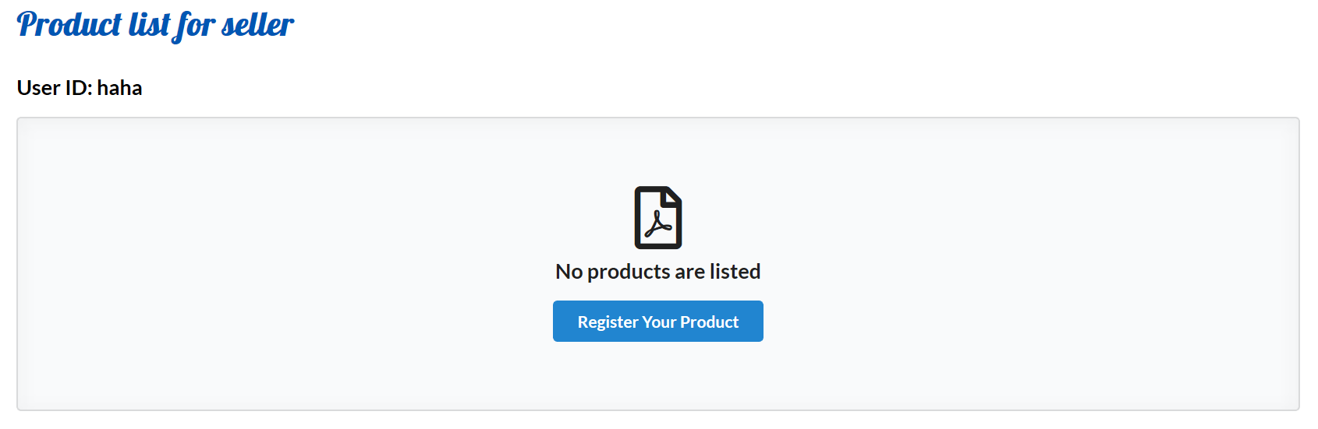

Seller needs to fill out the form to register the product to sell. Field with *mark is mandatory thing to enter the input. Seller can choose the way they want to sell the product in ‘Market Type’ field. Price of auctioned product is set to the current price of the auction. Auction Due field is for setting the end day of progressed auction, so it is not necessary to enter the input for flea market product.

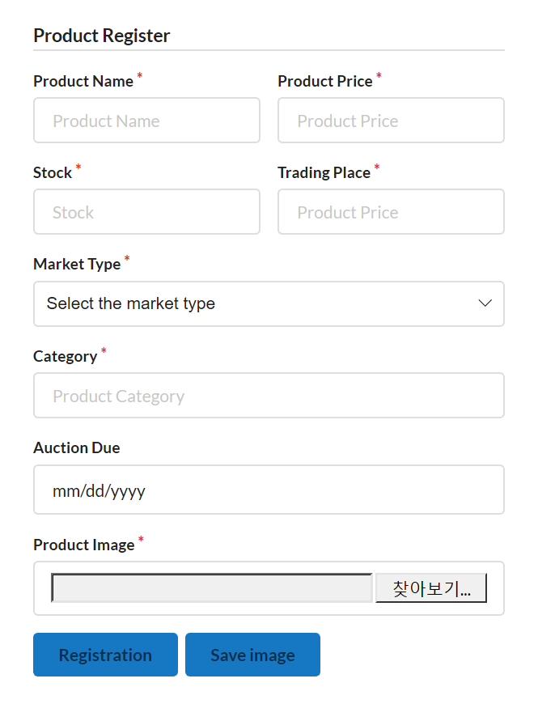 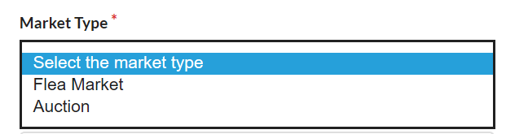

* **Product list**

Product list displays all the products the seller registered with product information (name, price, status etc).

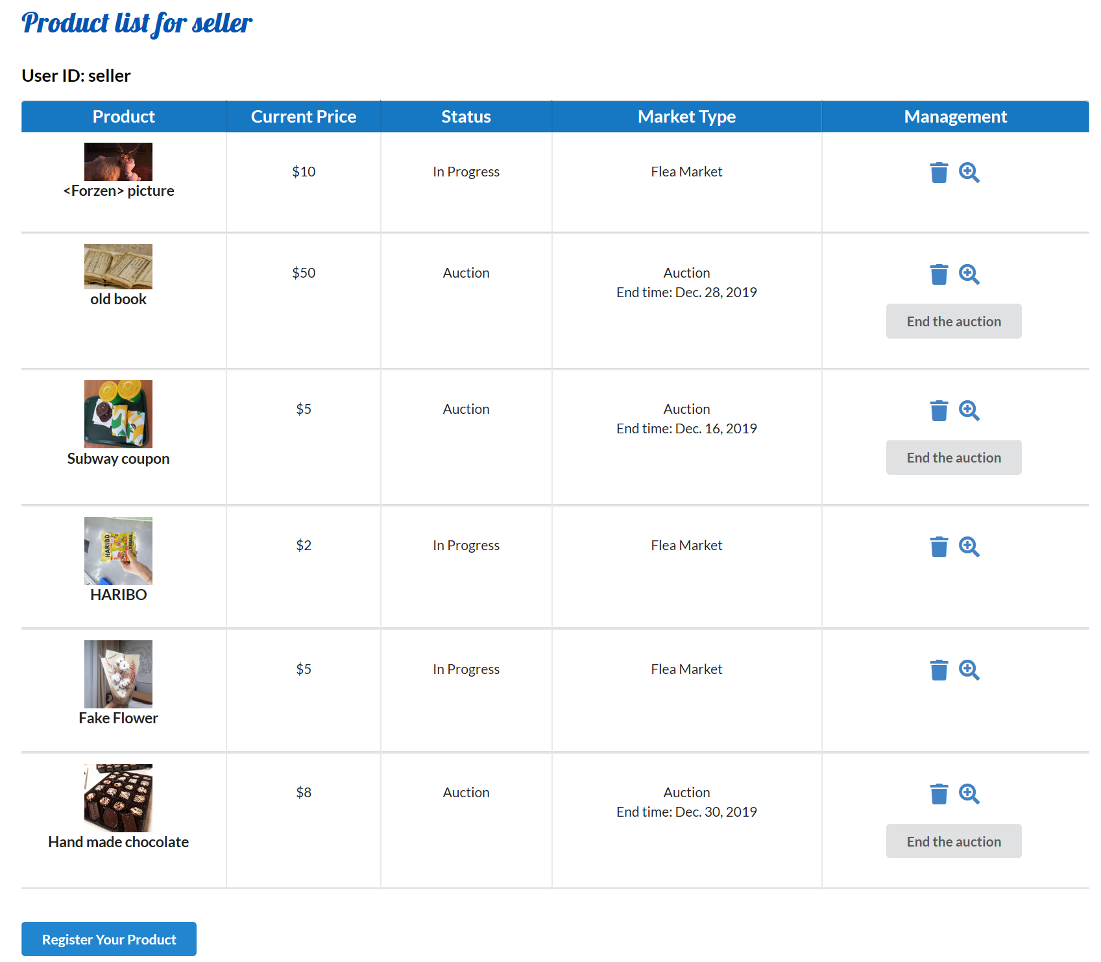

Seller can end the auction by clicking the ‘End the auction’ button. When the auction is ended by the seller, the status of product changes to ‘Purchased’. Also, the product is purchased by the winner of the auction who offers the highest price and the product is added to the buyer’s shopping list.

Seller can delete the product by clicking  this icon.



 this icon is linked to the page that shows who and how many buyers add the product to their wish list. Like the capture image below, the product named <Frozen> picture is added to wish list of a buyer whose name is ‘buyer’. For the auction product, the history of auction is shown that which buyer has bid for certain price.

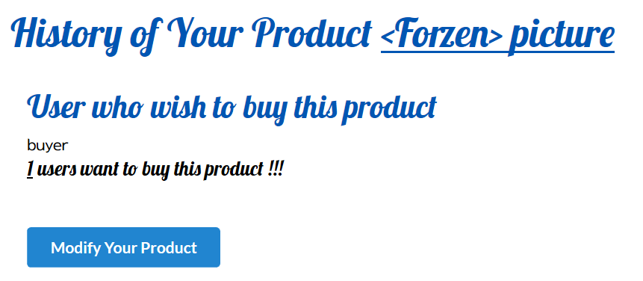

‘Modify Your Product’ button is linked to the modification page. The exist information of the product selected to be modified remains.

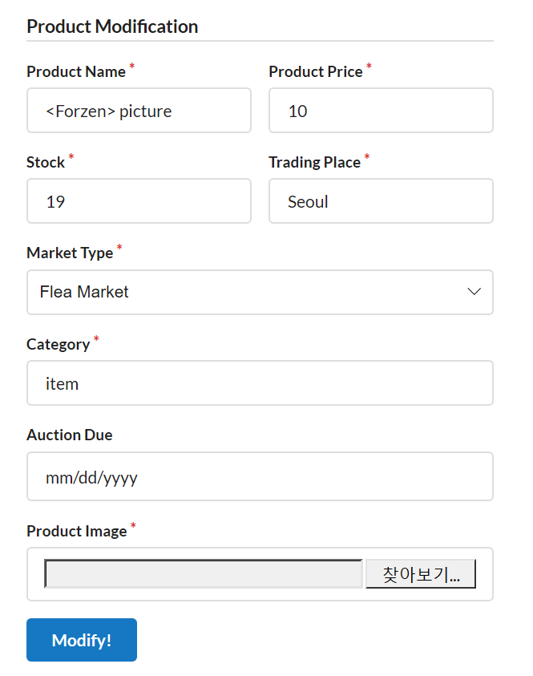

1. **Additional function**

* **Review**

Users can leave the comment of the product. The user’s name, type and the date are shown.

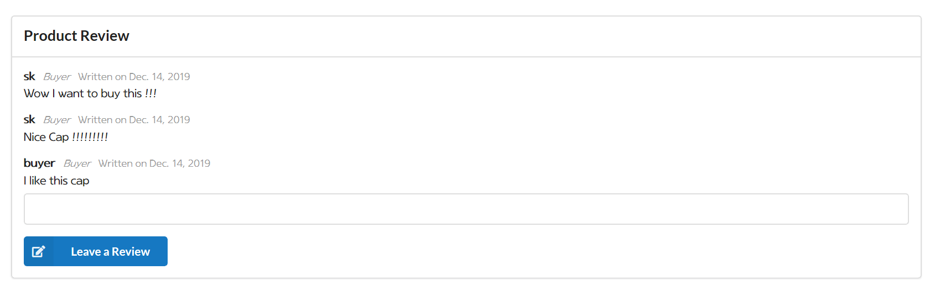

* **Products Alignment**

The user can align products based on three options: “new product”, “low price”, “high price.” If the user chooses “new product”, the products will be shown by the order based on the time when products are registered. “Low price” alignment option will show products from the lowest price to the highest price. “high price” option will show products from the highest price to the lowest price.

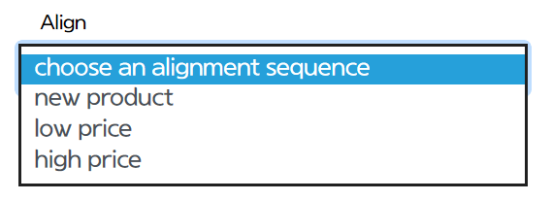

- alignment by choosing “new product” option

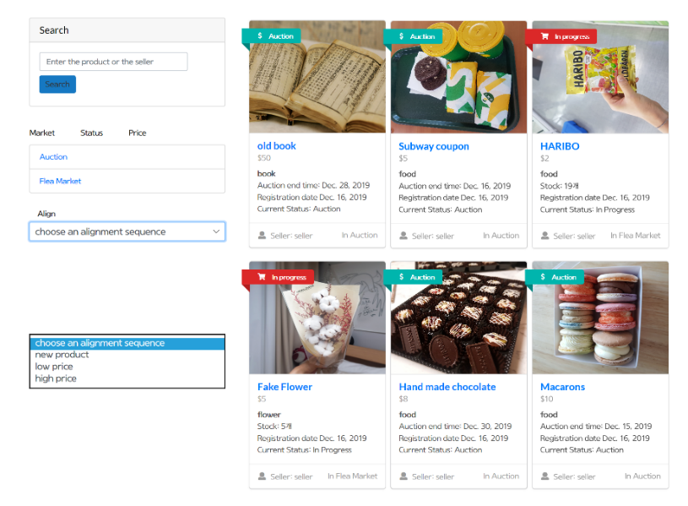

- alignment by choosing “low price” option

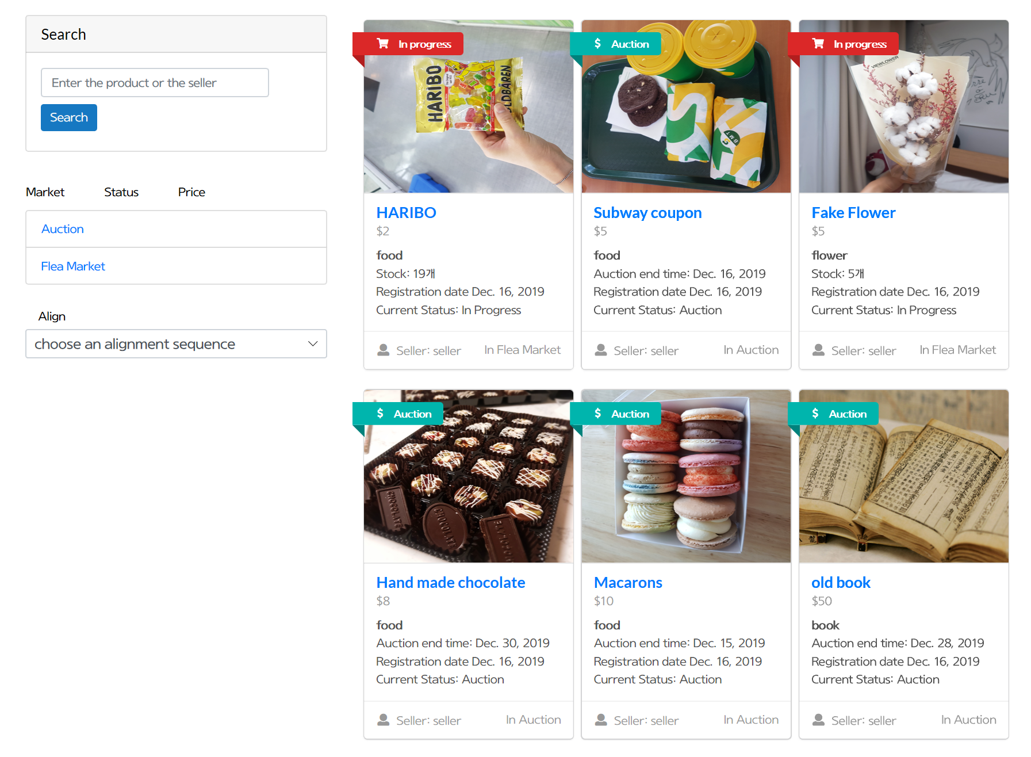

-alignment by choosing “high price” option

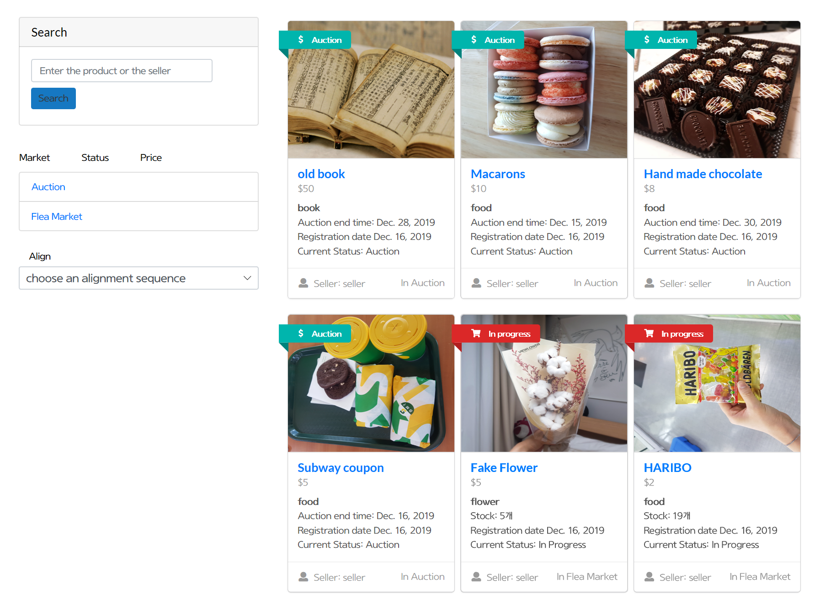

**#2 Database**

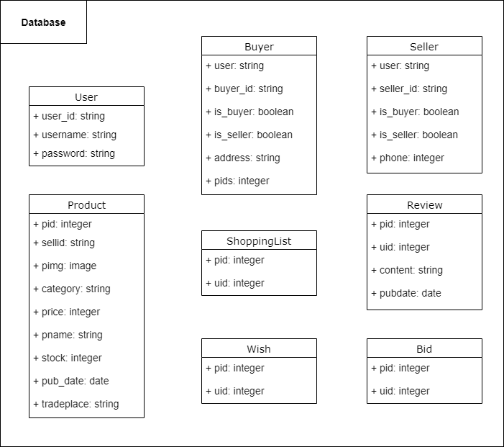

These are the tables used in the database for the project. Each row indicates a column of respective tables. Table ‘Buyer’ and ‘Seller’ refer ‘User’ table. ‘Product’ table is for products registered on the web site. ‘ShoppingList’ table is for each buyer’s purchase record and ‘Wish’ table is for each buyer’s record of the product on the wish list. ‘Review’ table is for the reviews written by users for each product. ‘Bid’ table is for the records that the buyer has bid for a certain price on the auction product.